How do I log in to ReadyRosie™ as a teacher or administrator?
Teachers or administrators can log in to ReadyRosie™ from ReadyRosie.com.
Jan 7, 2020•FAQs
Article Body
Teacher and Administrator Article
To log in to ReadyRosie™:
- Navigate to ReadyRosie.com. Note: Teachers and administrators cannot log in to the ReadyRosie™ mobile app.
- Select Sign In (1).
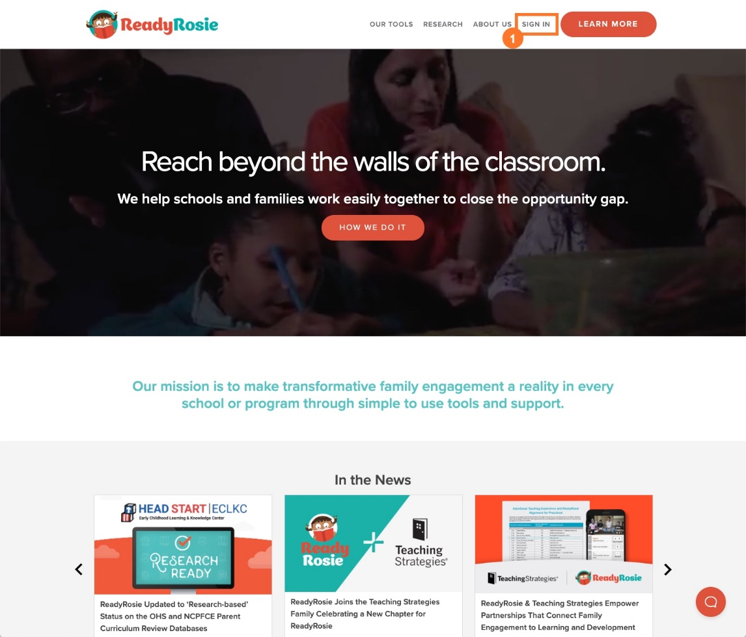
- Type in your username (your email address or mobile phone number) and password (1).
- Select Sign In (2).
- To change the language of the login screen from English to Spanish, use the toggle (3) at the top of the login screen.
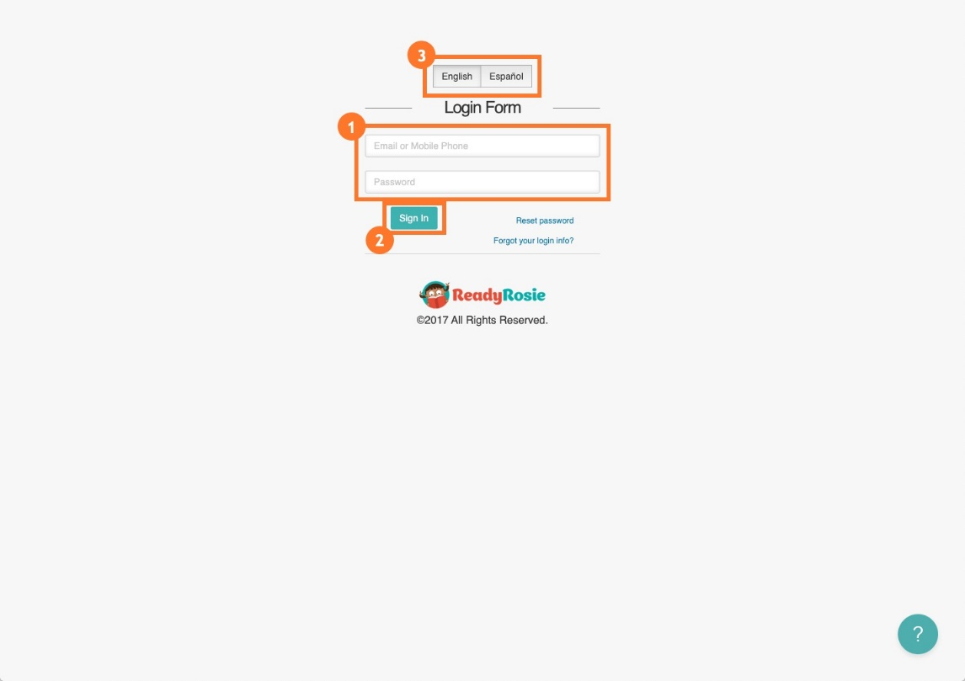
- Once you have completed these steps, you will automatically be logged in to ReadyRosie™ as a teacher or an administrator.
